To order more books by Allan C. Oggs, Sr. follow the link below to Amazon.
https://www.amazon.com/s?i=stripbooks&rh=p_27%3AAllan+C+Oggs+Sr&s=relevancerank&text=Allan+C+Oggs+Sr&ref=dp_byline_sr_book_1

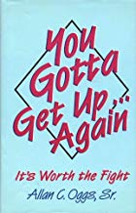
You Gotta Get Up...Again: It's Worth the Fight
Stricken with cerebral palsy since birth, Allan Oggs' life has been one of ongoing struggle, both with the physical limitations of his body and with the low expectations of others who have believed that he was not capable of being a preacher. With steadfast determination, he has defied all those expectations, successfully carrying out God's calling on him to minister for over 50 years.
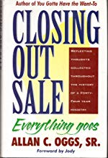

Closing Out Sale

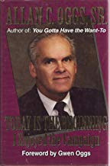
Today Is the Beginning I Enjoyed the Campaign

